## **Objectives**

* Explain React events

React events are actions that can be handled when a user interacts with elements in a React application. These include events like clicking a button, typing in a form field, or hovering over an item. React uses its own event system that is similar to DOM events but works consistently across all browsers.

* Explain about event handlers

Event handlers in React are functions that are triggered in response to user actions (events). They are written in camelCase and passed as props to JSX elements. For example, onClick={handleClick} is an event handler that calls the handleClick function when the element is clicked.

* Define Synthetic event

A Synthetic Event is a wrapper around the browser’s native event system in React. It combines the behavior of different browsers into a single API, so the same event works consistently regardless of the browser being used. Synthetic events are part of React’s internal event delegation system.

* Identify React event naming convention

React uses camelCase naming for events instead of lowercase. For example:

* HTML: <button onclick="handleClick()">
* React: <button onClick={handleClick}>

Also, event handlers are passed as functions, not as strings.

## **Notes**

Estimated time to complete this lab: **90 minutes.**

Create a React Application “eventexamplesapp” to handle various events of the form elements in HTML.

1. Create “Increment” button to increase the value of the counter and “Decrement” button to decrease the value of the counter. The “Increase” button should invoke multiple methods.
   1. To increment the value
   2. Say Hello followed by a static message.

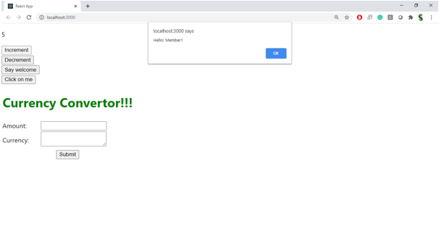

1. Create a button “Say Welcome” which invokes the function which takes “welcome” as an argument.

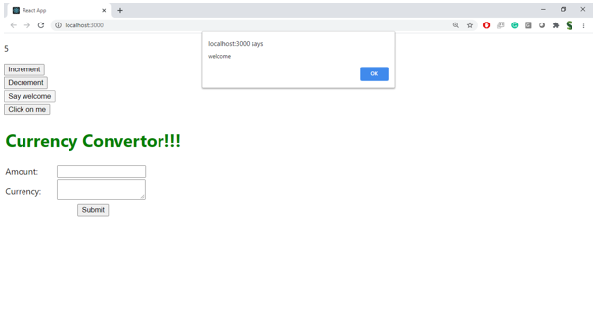

1. Create a button which invokes synthetic event “OnPress” which display “I was clicked”

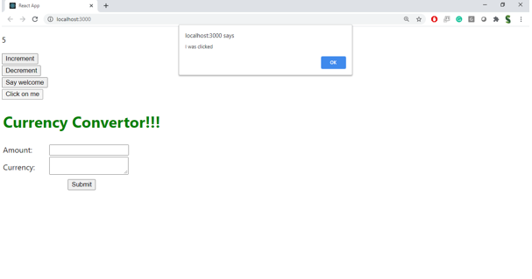

Create a “CurrencyConvertor” component which will convert the Indian Rupees to Euro when the Convert button is clicked.

Handle the Click event of the button to invoke the handleSubmit event and handle the conversion of the euro to rupees.

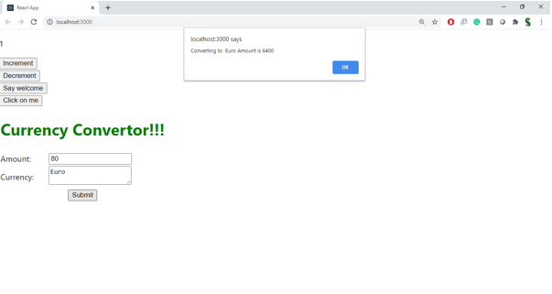

HANDSON:

